Brian Albert

Intro to Computer Graphics

A Rube Goldberg Machine in Blender

[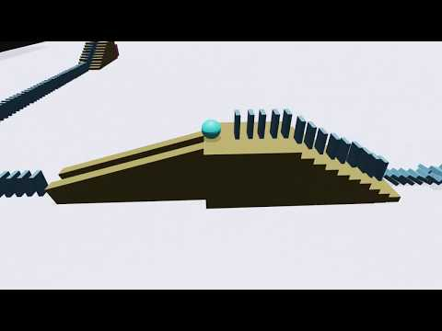](https://www.youtube.com/embed/6PWC--vvSUY?feature=oembed)

A Rube Goldberg Machine is a machine that is designed to perform a simple task in an overly complicated way. Growing up I would always see YouTube videos of these machines. I wanted to take this idea and design my own Rube Goldberg machine in the 3D creation software called Blender. My goal was to include ramps, dominos, and pipes that would inflate a balloon at the very end.

Because I had no previous experience with Blender, I started by watching a YouTube video that explained the basics of Blender and how I can navigate the software. Blender has a YouTube channel and they have a playlist that includes tutorials that help beginners with using Blender. The first thing I did after I knew some of the basics was model the domino. This was very easy because of the simplicity of a domino so all I had to do was transform a cube into a rectangular prism that was the shape of a domino. I also created a plane that acted as a floor for the dominos.

Next, I worked with the physics of the domino. I had to make both the domino and the plane have rigid body physics, but I had to set the plane as passive so it would not fall. The next step I took was duplicating these dominos and setting them up in place. Up to this point, I had no real challenges.

After setting up some dominos, I focused my attention on creating a pipe that a ball would be able to go through. This part was difficult because of the curves in the pipe when modeling. Once I was able to find the shape I was looking for, I set up the physics so the ball would roll through the pipe. To make the machine more interesting, I added some features like multiple dominos in a line, stairs the dominos can go up on, and a ramp with a ball that will hit into the next set of dominos. Following this, I created a cube that I wanted to inflate after a domino hits it. For this step, I had to change some of the cubes properties and included a cloth physic to the cube that would make it appear as if it were inflated. I then had to match the timing that this physic would activate with the time the domino hits the cube.

To make the simulation look nicer I changed the textures of the objects. This step was simple, but if I had more time, I would have liked to include more realistic textures like dots on the dominos and translucent pipes. After this, I started setting up cameras to follow the machine as it goes. To do this I set up where I wanted each camera to look and, on the timeline, I added timestamps for when the cameras would switch.

Lastly, I had to render the animation. My first-time rendering, I ran into a couple of problems. The physics would stop randomly and the timing of when one camera would switch to the next was off. To fix this I went back into the animation and baked all the dynamics. This means that Blender computed some of the processes before I rendered. After that I had to make sure the camera changes were timed properly. They were off because I was messing around with the fps of the render. After making these changes I finally had the render I was looking for.

The most difficult parts of this project were modeling the pipes, getting all objects aligned for the final animation, and rendering the simulation. Now that the Rube Goldberg machine has been completed, I feel much more comfortable with Blender and the many uses it has.

Sources:

<https://www.youtube.com/watch?v=MF1qEhBSfq4&list=PLa1F2ddGya_-UvuAqHAksYnB0qL9yWDO6>

<https://www.youtube.com/watch?v=8e_K2VjBhVg>

<https://www.youtube.com/watch?v=R5aUkq8kVDg&t=836s>

<https://www.youtube.com/watch?v=SD6mzAQ8tq0>

<https://www.youtube.com/watch?v=zua2AfUonYU>